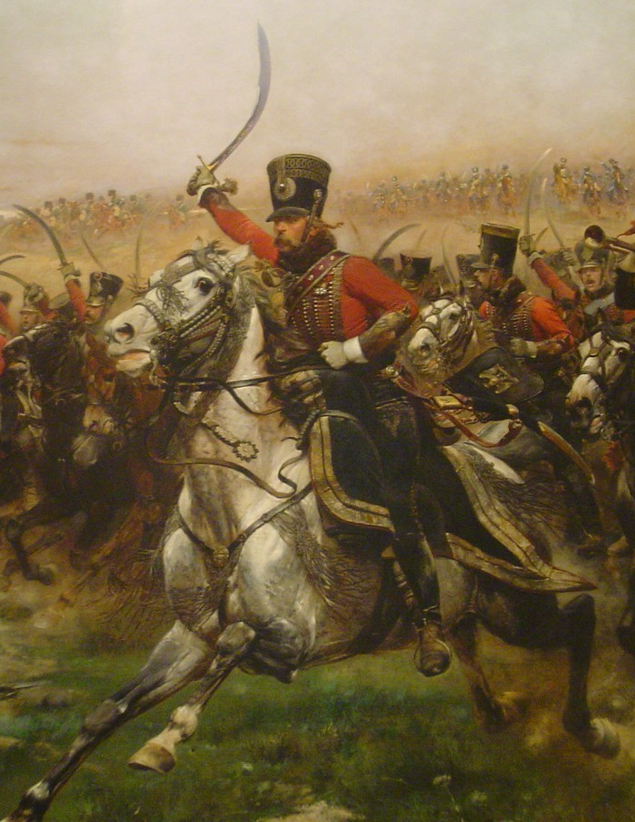
Napoleonic Strategy Battle Game

An Adaptation of
The Lord of The Rings Strategy Battle Game
by Scott Cameron

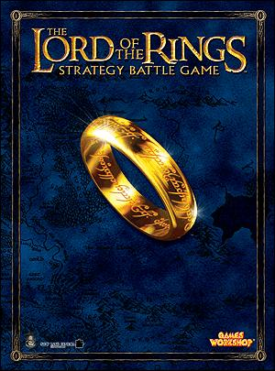
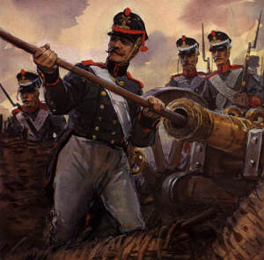
Napoleonic Strategy Battle Game

Version 1.2
This is an adaptation of the Lord of the Rings Strategy Battle Game to play skirmish-level wargames in the Napoleonic Period. These rules can also be used for the Seven Years War, revolutionary War, or the War of 1812, with suitable profiles invented. A copy of Games Workshop’s ‘One Rulebook’ is needed to play the game.
All Infantry are mounted on 25mm round bases. All Cavalry are mounted on 40mm round bases.
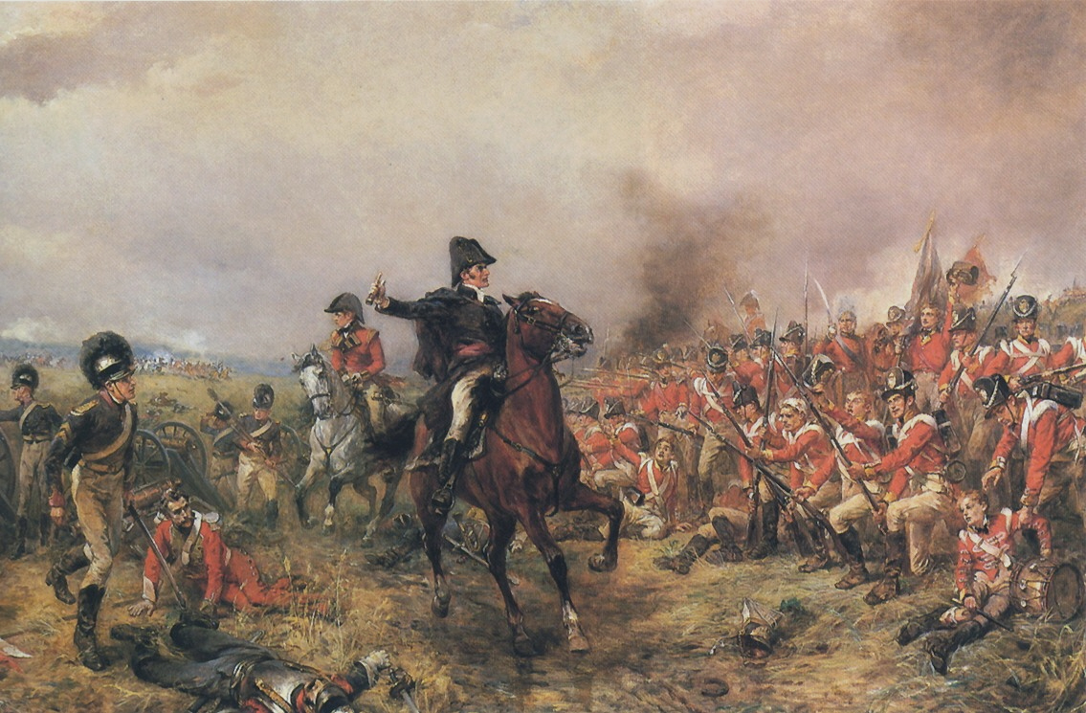
ALL MEASUREMENTS ARE IN INCHES.

Priority Phase
Identical to LotR, except the winner of the dice roll chooses to go first or second.

Move Phase
Rules are identical to LotR.

Shoot Phase:
Different Weapon profiles are used, as well as the following exceptions.
Weapon | Range (Inches) | Half Range Strength | Full Range Strength | Movement Penalty | Scatter
Bow | 24 | 3 | 2 | 1/4 | None
Carbine | 24 | 4 | 3 | Half | 6
Musket | 30 | 4 | 3 | Half | 6
Rifle | 40 | 5 | 4 | Full | None
Rifled Carbine | 34 | 4 | 3 | Full | None
Blunderbuss | 16 | 3 | 2 | Full | Template
Volley Gun | 20 | 4 | 3 | Half | 6”
Pistol | 12 | 3 | 2 | Half | 3

In the Way!
A modified “In the Way!” table is used.
Dice Roll | Types of Cover
3+ | Split rail fence, bushes, hedges, etc.
4+ | Solid fences, low wall, crates, barrels, windows of building, rocky outcroppings, etc.
5+ | High walls, small windows, large boulders, trenches, etc.

Friends and ‘In the Way!’
Both sides may risk hitting their own models.
Models may fire though two friends, instead of only one. This represents the first man kneeling, the second crouching, and the third standing. The normal rules apply to models with bows – they can only fire through one friend. This represents the extended reach of the firearms.

Moving and Shooting
Riflemen and cavalrymen may, if they wish to move and shoot, sacrifice the turn before to load their weapons. They may not Move, Shoot, or Fight this turn. The next turn, they may move up to half of their maximum movement value – they do, after all, still have to aim.

Differences of Range
The shoot value given in the profile is for at Half to Full range – i.e. for a musket, 12-24”. Subtract 1 from the shoot value if the target is within Half range.
Use the Half Range Strength for targets at nearer than half the maximum range, and the Full Range Strength for targets between Half and Full range.

Brace of Pistols
If a model carries a brace of pistols, he may shoot two shots instead of one in his turn, provided that he does not move. He may fire only one shot as usual, if desired.

Blunderbuss
A D6 is rolled for each model within 2” of the target model, starting with the model nearest the shooter. Roll 1D6 for the rider and 1D6 for the mount in the case of cavalry. On a 5+ (ignoring any bonus for range), this model takes a hit at the strength according to the range from the shooter. Work out any “In the Way” rolls, and then move on to the next nearest model. Hits may only be allocated to models within 45 degrees of the target model. See illustration for details. A model armed with a blunderbuss may only shoot over one friend’s shoulder.

Volley Gun
A model armed with a volley gun may use it normally, or may, once per game, fire all seven barrels. If a player decides to fire all seven barrels, the model may only move half their maximum movement value. A 4” diameter template is placed over the target. For each model under the template, a D6 is rolled. The target models are chosen first by the opposing player, then the controlling player, and so on. On a 4+, the model is hit, and the hit is resolved, remembering to work out any “In the Way” rolls. Each model may be hit twice. This continues until the potential targets have been exhausted or seven hits have been allocated. Hits may only be allocated to models within 45 degrees of the target model. See illustration for details. A model armed with a volley gun man only shoot over one friend’s shoulder.
45°

45°

Target Model

Valid Targets are in Red.
Invalid Targets are in Blue.

Cavalry and Shooting
See the Cavalry Section.

Scatter
If there is a value given for scatter, a roll must be made on the scatter chart for each successful hit. See ‘The Fortress: Siege Engines’ for details. A modified Scatter chart is used. Hits may only be allocated to models within 45 degrees of the target model, as shown in the diagram previously.
1-2 Enemy Models within Scatter Range |  | 3-5 Enemy Models within Scatter Range |  | 6+ Enemy Models within Scatter Range
Roll | Result | Roll | Result | Roll | Result
1 | Your opponent may nominate one of your Battlefield Targets or a Siege Target within Scatter Range of the initial target as the new target. If no alternative target is within Scatter Range, or the player does not wish to do this, the shot misses completely. | 1 | Your opponent may nominate one of your Battlefield Targets or a Siege Target within Scatter Range of the initial target as the new target. If no alternative target is within Scatter Range, or the player does not wish to do this, the shot misses completely. | 1 | Your opponent may nominate one of your Battlefield Targets or a Siege Target within Scatter Range of the initial target as the new target. If no alternative target is within Scatter Range, or the player does not wish to do this, the shot misses completely.
2-4 | The shot misses completely. | 2-3 | The shot misses completely. | 2 | The shot misses completely.
5 | The shot hits another enemy model within Scatter Range, as chosen by the opponent. | 4-5 | The shot hits another enemy model within Scatter Range, as chosen by the opponent. | 3-5 | The shot hits another enemy model within Scatter Range, as chosen by the opponent.
6 | The shot hits the original target. | 6 | The shot hits the original target. | 6 | The shot hits the original target.

Optional rules for larger games
The Rules given are for smaller Skirmish level games. If playing larger games, they can bog down the action considerably.
In a larger game, do not roll on the scatter chart for small arms. Instead, add one to the shooter’s shoot value. For example, a British Line Infantry in a larger game would hit on a 6 at Half range or more, and on a 5 at half range or less.
This does not apply to weapons that do not normally scatter – rifles and bows will still roll to hit without this penalty.
This change does not apply to Cannon.
Whether or not a game is a ‘large game’ or not is up to the player’s or the moderator’s discretion.

Wound Chart
Also, an expanded and modified wound chart is used.
Strength | Defence
 |  | 1 | 2 | 3 | 4 | 5 | 6 | 7 | 8 | 9 | 10 | 100
 | 1 | 4 | 5 | 5 | 6 | 6 | 6/4 | 6/5 | 6/6 | - | - | -
 | 2 | 4 | 4 | 5 | 5 | 6 | 6 | 6/4 | 6/5 | 6/6 | - | -
 | 3 | 3 | 4 | 4 | 5 | 5 | 6 | 6 | 6/4 | 6/5 | 6/6 | -
 | 4 | 3 | 3 | 4 | 4 | 5 | 5 | 6 | 6 | 6/4 | 6/5 | -
 | 5 | 3 | 3 | 3 | 4 | 4 | 5 | 5 | 6 | 6 | 6/4 | -
 | 6 | 2 | 3 | 3 | 3 | 4 | 4 | 5 | 5 | 6 | 6 | -
 | 7 | 2 | 2 | 3 | 3 | 3 | 4 | 4 | 5 | 5 | 6 | -
 | 8 | 2 | 2 | 2 | 3 | 3 | 3 | 4 | 4 | 5 | 5 | -
 | 9 | 2 | 2 | 2 | 2 | 3 | 3 | 3 | 4 | 4 | 5 | -
 | 10 | 1 | 2 | 2 | 2 | 2 | 3 | 3 | 3 | 4 | 4 | 5
 | 11 | 1 | 1 | 2 | 2 | 2 | 2 | 3 | 3 | 3 | 4 | 5
 | 12 | 1 | 1 | 1 | 2 | 2 | 2 | 2 | 3 | 3 | 3 | 5
 | 13 | 1 | 1 | 1 | 1 | 2 | 2 | 2 | 2 | 3 | 3 | 4
 | 14 | 1 | 1 | 1 | 1 | 1 | 2 | 2 | 2 | 2 | 3 | 4
 | 15 | 1 | 1 | 1 | 1 | 1 | 1 | 2 | 2 | 2 | 2 | 4

Note: This Wound Chart uses a steeper power curve than the standard LotR Chart. It simply did not feel right to have models surviving cannonballs hitting them!

Combat
Combat is carried out the same as in LotR, with following exceptions.
If a model is armed with multiple weapons, then he will use the one of the controlling player’s choice.
Wargear | Effects
Musket/ Rifle/Carbine/ Blunderbuss without bayonet  Pistol/ Dagger | -1 penalty to determine winner of combat.
Musket/ Rifle/Carbine with bayonet | Model uses the gun as a spear.
Sword/ Short sword | Hand weapon. Pistols are included here because they can be flipped around and used as clubs.
Two Handed Weapon | Same as in LotR, except models armed with a two handed weapon may also carry a ranged weapon, though they may not use both in the same turn.
Spears | Used as in LotR, unless against Cavalry. See Cavalry section for further details.
Pike | Used as in LotR, with the following exception.  If a pikeman is in combat, he suffers a -1 penalty when determining the winner of the combat. This represents the awkwardness of fighting someone nearby with a fifteen-foot pike.  There is no penalty if the pikeman is supported by one or more spearmen or pikemen.
Lance | Used on the charge on horseback, it gives a +1 bonus when rolling to wound, as in LotR SBG.  When charging on horseback, the lance also negates the benefits of spears against cavalry.  If the cavalry model is charged, then it suffers a -1 penalty when determining the winner of a fight, unless it is also armed with a sword, pistol, dagger, etc.  If a cavalryman armed with a lance is unhorsed, the lance becomes a pike.
Helmet | If a model is depicted as wearing a helmet, then he receives a ‘Helmet Save’ bonus. If he suffers a wound, then a dice is rolled. On a 6, the wound is ignored as if saved by a Fate point. Wounds suffered from Round Shot from Cannon or Explosive Shot from Howitzers may not receive this save, though those receiving the area effect of an explosive round may. This rule is purely ‘What you see is what you get.’ If the model is depicted wearing a helmet, it receives this bonus.

Grenades
Grenades were iron bombs as crude as they were volatile. Grenades were not widely used in the Napoleonic Period, and their rules are given for scenario specific purposes or for adaptation of the rules to other periods – though they may be used by Spanish Guerrillas.
Note: D2 means Roll a D6, and divide the result by 3, rounding up. A roll of 1, 2, or 3 becomes a 1, and a roll of 4, 5 , or 6 becomes a 2.
Grenades may be thrown if the model who wishes to throw the bomb does not move or shoot. They have a range of twice the thrower’s strength.
If, when rolling to hit, the controlling player rolls a 1, he not only misses his target, but he may have blown himself up! Roll a further D6. If the result is less than or equal to the thrower’s Fight Value, then the grenade has not blown up. These rolls can be changed by Might. The model takes a blow of Strength 5. All models within D2” of the target take a hit of Strength 3 as they are blasted with shrapnel.
If the grenade hits, the controlling player mist roll a D6 to see if the grenade is a dud – the fuse could be blown out in transit. On a roll of a 1, the grenade is a dud. The target model takes a hit of Strength 1.
If the grenade is not a dud, the targeted model takes a blow of Strength 5. All models within D2” of the target take a hit of Strength 3 as they are blasted with shrapnel. Any model lying prone or with hard cover between them and the grenade are only hit on a 4+, as the cover is ‘In the Way.’
If a grenadier is shot, there is a risk that the bullet will detonate his grenades. Before rolling to wound, roll a D6. If the result is a 1, roll a further D6. If a 1, 2, or 3 is rolled, his grenades have detonated. The model takes a blow of Strength 7. All models within D3” of the target take a hit of Strength 4 as they are blasted with shrapnel.

Banners
The rules for banners are the same as in LotR, with the following exception.
Captured banners have the same effect as a banner of one’s own side – a captured enemy banner is just as effective as one’s own.
If a banner bearer is killed in close combat, then any model involved in the fight on the opposing side may take the banner. If a model on the same side as the hapless banner bearer wishes to pick up the standard, then a number of D6 equivalent to the model’s Attack value is rolled by both models. The one who rolls a higher score gets the standard, and ties are resolved by Fight Value.
If a banner bearer is defeated in close combat, then the victor may attempt to wrest the banner from its bearer. A number of D6 equivalent to the model’s Attack value is rolled by both models. The one who rolls a higher score gets the standard, and ties are resolved by Fight Value.

Courage
The Courage Rules are the same as LotR, with the following exceptions.

Sphere of Influence
If a model is within any one of his comrade’s Sphere of Influence at the beginning of his turn, the model gains a +1 increase to his courage. Note that models only benefit from teammates of equal or greater rank than themselves. E.g. An officer will only receive this bonus from officers within 12”.
Rank | Sphere of Influence
Private | 6”
Non Commissioned Officer (NCO) | 6”
Officer | 12”
Note that these benefits are not cumulative – a soldier can only receive the +1 bonus once, no matter how many Spheres of Influence he is in.

Other Courage Bonuses
The following benefits are cumulative.
If any unit has a banner within 3” of him, he gains a +1 increase to his courage.
If a Musician is within 12”, all privates gain a +1 increase to their courage.
If a general is within 24”, all units of lesser or equal rank gain a +1 increase to their courage.
Note that Banner Bearers give their courage bonuses to themselves, while Musicians do not.
Note also that Musicians and Banner Bearers can be Privates or NCOs.
This means that a private can potentially gain a +4 bonus to his courage, an NCO can potentially gain a +3 bonus to his courage, an Officer can potentially gain a +3 bonus to his courage, and a General can potentially gain a +2 bonus to his courage.

Broken
The Return of the King rules for Broken Forces are used. This means that if a model flees because his force is broken, he will not be automatically removed, but rather he flees towards the nearest board edge. If he is in combat, and wins, he will not strike blows, and once he reaches the edge of the board, he will leave the battlefield.
If a model fails a Courage Test for the force being Broken, all models of lesser rank within his Sphere of Influence receive a -1 penalty to their Courage, instead of the +1 bonus that would normally be bestowed. These models may still benefit from another Hero’s Stand Fast!, but they may not gain the Sphere of Influence Bonus from any other models.
I.e. if an Officer fails his Courage Test, all NCOs and Privates within 12” receive a -1 penalty to their courage.

‘Alone’
If a model is on his own at the beginning of his turn, with no friendly models within 6” of himself, he must take a Courage Test. If it is passed, he may be controlled as normal. If it is failed, a further D6 is rolled. Might cannot be used to affect this roll. If it is between 1-3, the model flees towards the nearest board edge as described above. If it is between 4-6, then the model flees towards the nearest friendly model. If he is in combat, and wins, he will not strike blows.

Stand Fast!
Stand Fast! Rules are unchanged from the LotR rules apart from the following: NCOs only have a Stand Fast range of 3”. NCOs may also benefit from the Stand Fasts! of Officers.

Dive for Cover!
If a model is hit by a ranged attack and not killed by it, or if a model within 3” of him is killed by a ranged weapon, then he must immediately take a Courage Test. If passed, the model may continue as normal. If the test is failed, then he must dive for cover. He must move his full move towards the nearest piece of scenery that will put something in between him and the enemy. This movement is done in the shoot phase, immediately after each shot is taken, even if the model has already moved. If the model is already behind cover, he must lie down. If the test is failed, the model may do nothing further that turn.
Mounted Models will test with the Rider’s Courage value. Instead of lying down, the model will dismount, and hide behind his mount.
If a model is knocked to the ground by a ranged weapon, such as a howitzer or cannon, then the Dive for Cover rules are negated.

Loose mounts
Loose mounts follow the same rules as in LotR, except mounts with 0 attacks will remain on the battlefield if their riders dismount or are killed. Each turn they must pass a Courage Test, as in LotR. If this is failed, they are not removed instantly, but rather flee towards the nearest board edge. The exception to this is if their original rider or a similar model is within 2” of them, in which case they will pass the Courage Test to stay in the fight. For example, if a Heavy Dragoon dismounts, then his horse will pass its Courage Tests if there is a Heavy Dragoon (of any rank) within 2” of it.

Cavalry
The Cavalry rules are the exact same as in LotR, with the following exceptions.

Cavalry and Shooting
Cavalrymen must sacrifice all movement in order to shoot. If they are armed with Bows or Pistols, then they must sacrifice half their movement. Cavalry may not carry Muskets, Rifles, or a Brace of Pistols.
Cavalrymen may, if they wish to move and shoot, sacrifice the turn before to load their weapons. They may not Move, Shoot, or Fight this turn. The next turn, they may move up to half of their maximum movement value – they do, after all, still have to aim.

Cavalry and Walls of Spears
If a cavalry model wishes to into a combat against two or more spearmen (a model supported by a spear and armed with a spear, or armed with a hand weapon and supported by pike and spear), then the cavalry model must pass a Courage Test exactly as if the enemy caused courage.
If the test is passed, the cavalry may charge into combat.
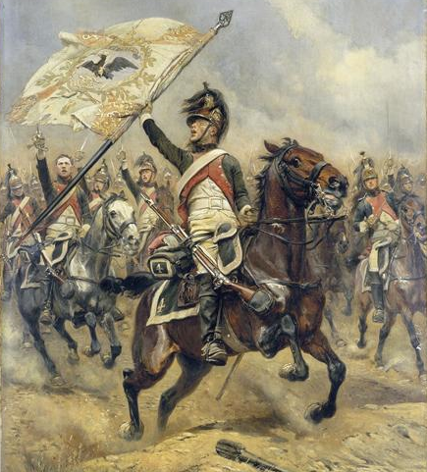
A die is then rolled by the defender. If it is lower than the highest defender’s Fight Value, the horse takes 1 automatic hit of Strength 4 for every spearman past the first. If the horse survives, the combat proceeds as usual. If the horse is killed, then the rider rolls on the Thrown Rider Chart. If anything but a 6 is rolled, the rider may not strike blows if he wins the combat.
This bonus is negated if the cavalry model carries a lance.

Cannon!
Note – this section is parallel to the Siege Engines section of the main rulebook.
Type of Cannon | Range | Half Range Strength | Full Range Strength | Scatter | Min. Crew | Defence | Batter Points | Grape Shot Radius | Canister Shot Radius | Canister Shot Range
3 Pdr | 36 | 8 | 7 | 4 | 2 | 9 | 3 | 1 | 1.5 | 12
6 Pdr | 42 | 9 | 8 | 6 | 3 | 9 | 3 | 1 | 2 | 14
9 Pdr | 48 | 10 | 9 | 6 | 3 | 10 | 3 | 1.5 | 3 | 16
12 Pdr | 54 | 11 | 10 | 6 | 4 | 10 | 4 | 1.5 | 3 | 18
18 pdr | 66 | 13 | 12 | 6 | 5 | 10 | 4 | 2 | 3.5 | 22
24 pdr | 80 | 15 | 14 | 6 | 5 | 10 | 5 | 2.5 | 4 | 27
Howitzer | 38 | 10 | 9 | 6 | 3 | 10 | 3 | 2.5 | 4 | 12
“Pdr” is an abbreviation for “Pounder,” indicating the weight of the shot the cannon fired.
Historical note – Not all nations used the same 3, 6, 9, 12 pattern for the sixing of their cannon. France, for example, used 4, 6, 8, and 12 pounder cannons. Each weight, for the sake of this game, has a ‘give or take’ 1 rule. This means that a 2 pdr cannon or a 4 pdr cannon use the same rules as a 3 pdr cannon.
Cannons have profiles in the same way that siege engines do. They are given here, and repeated in the actual profiles.
The profile is for short-barrelled howitzers of a caliber of about 6”, such as the 5.5” howitzer of the United Kingdom, or the French 6” howitzer. Different statistics should be created for different calibre howitzers.

Moving Cannon
Cannon may be moved at half speed by the half the number of models, rounded up, indicated in the Min. Crew column. If there are more than half the Min. Crew, rounded up, the cannon may be moved at the full speed of the slowest model. If there are less than half the Min. Crew, the cannon may not move.
The exception is for 18 and 24 pdr cannons. These guns are so heavy that the number indicated in the Min Crew column is the number of soldiers that it takes to move at half the speed of the slowest model. They may not move any faster than half speed, no matter how many models are in base contact.
E.g. A 12 pdr cannon has 4 crew. It may move at the full speed of the slowest miniature. One crewman is killed, and now the cannon may move at half speed. If another crewman is killed, leaving two surviving, the cannon may not fire.

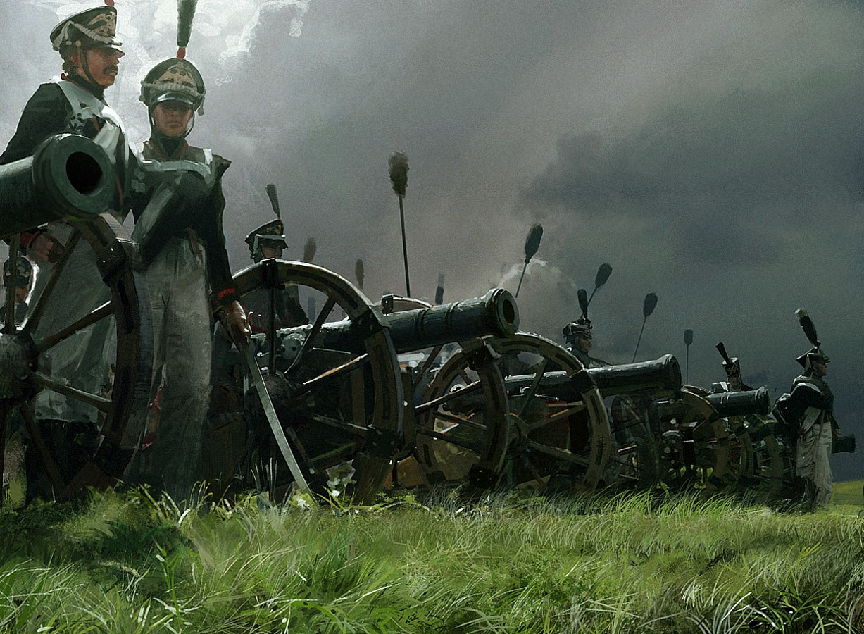
Firing Cannon
A cannon may be fired once per turn provided that it has the minimum number of crew in base contact with it, and none of them have moved. At least one crewman must have Line of Sight to the target.
All cannon hit on a 5+ unless otherwise specified in the cannon’s profile. If the target is within half of the maximum range, then the value for “Half Range Strength” is used, and the cannon gains a +1 modifier to its roll to hit. If the target is within 1/4 of the maximum range, then a further +1 modifier to its roll to hit is gained.
If the target is a Siege target, the roll to wound and the roll on the batter chart are made exactly as in LotR, except the Batter chart is changed.
Batter Chart
Dice | Result
1 | No effect – the blow rebounds harmlessly off the hard surface.
2-5 | Damaged - You have scored 1 Batter Point of damage on the target. Strikes with a Strength of 10 cause 2 Batter Points, and strikes of Strength 13 cause 3 Batter Points.
6 | Broken in - You have scored 2 Batter Point of damage on the target. Strikes with a Strength of 10 cause 4 Batter Points, and strikes of Strength 13 cause 6 Batter Points.
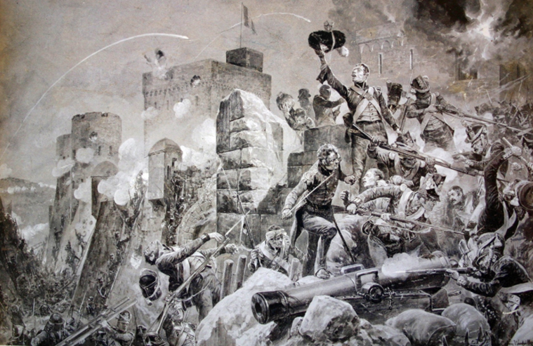
If the target is a Battlefield Target, then a roll must be made on the Scatter Chart exactly as in LotR. The modified Scatter Chart is used.

Friends in Proximity and In the Way
The same as LotR, with the following exceptions.
Both sides may risk hitting their own units.

Rolling to Wound
Identical to LotR. If a model is hit by a cannon, then it is knocked to the ground. If it is wounded, it is killed outright, no matter how many wounds it has.

Trained and Untrained Crew
Trained crew may use any cannon. If any member of the crew firing a cannon is untrained, the cannon will hit only on a 6, regardless of the range.

Types of Shot
All cannon come standard with Round Shot. Grape shot and Canister Shot may be bought as upgrades, for points costs given in the profiles.
Type of Shot | Effects
Round Shot | A simple cannonball. This can easily pass through a man. After it has been determined which model is hit, use a tape measure or similar device to show the line between the cannon and the target model. Every model on this line has the potential to be hit.  Starting with the first model on the line, roll a dice for an ‘In the Way’ test. If a 4+ is rolled, then the model has been struck by the cannonball. If the model is survives, the cannonball stops. If the model is killed, the cannonball continues. Deduct 1 from its Strength and 2 inches from its range for each model killed this way. When the cannonball‘s Strength value reaches 0, its range reaches 0, or it fails to kill a model, the cannonball stops. In this way, Round Shot can devastate columns of models.
Grape Shot | A group of several tennis ball sized iron balls, held together in a canvas bag that disintegrates before leaving the cannon. Can only be used against Battlefield Targets. Range is ½ of the maximum given for solid shot. No roll for scatter is made. The target model and all those within the “Grape Shot Radius” are hit on the roll of a 4+, and if hit receive a blow of Strength 6. Models that are “In the Way” take a Strength 6 hit, and reduce the Grape Shot Radius by ½”. Models struck with Grape shot are not killed outright, nor are they knocked to the ground. In the case of cavalry, roll 1D6 for the rider and 1D6 for the mount in the case of cavalry.
Canister Shot | A canister of musket balls, nails, glass, and wire that disintegrates when fired, turning the cannon into a giant shotgun. Can only be used against Battlefield Targets. Range is 1/3 that of Round Shot. No roll for scatter is made. The target model and all those within the “Canister Shot Radius” are hit on the roll of a 4+, and if hit receive a blow of Strength 6. Models that are “In the Way” take a Strength 4 hit, and reduce the Canister Shot Radius by ½”. Models struck with Grape shot are not killed outright, nor are they knocked to the ground. In the case of cavalry, roll 1D6 for the rider and 1D6 for the mount in the case of cavalry.
Howitzer | Howitzers may fire round, grape, canister shot, or their own unique ammunition. They can fire a shell that is filled with gunpowder that explodes after a time delay, determined by the length of the fuse. This round is lobbed at the target, so only obstacles that are in base contact with the target model count as being In the Way. A howitzer may fire at any target that any friendly model has Line of Sight to that is within range. The target must be at least 15” away from the Howitzer, up to a maximum range of 80”.  The round is rolled to hit normally. After the roll for Scatter, another test is made to determine if the fuse has been cut to the right length. A D6 is rolled, and on the roll of a 1, the shot has no effect – the round detonated too soon. If a 2+ is rolled, the shot is carried out as described.  The model struck suffers a hit of Strength 12. This kills outright if the model is wounded once and knocks him to the ground if he survives. All models within D3” are dealt a blow of Strength 2D6. This does not kill outright if wounded once, but it does knock to the ground. Any model lying prone or with hard cover between them and the site of the hit are hit on a 3+, as the cover is ‘In the Way.’  If used against a siege target, a Howitzer has a Strength of 2D6.  Howitzers may fire at targets that they or their teammates do not have Line of Sight to.  If a friendly unit has Line of Sight to an enemy model within 12” of the target, then the howitzer may bombard that area in the suspicion that there are enemy troops there. If the target model is hit, a roll for scatter is made, except the round may scatter up to 10”, and the Scatter Chart for Rockets is used. (See pg. 18)

Modifying Cannon
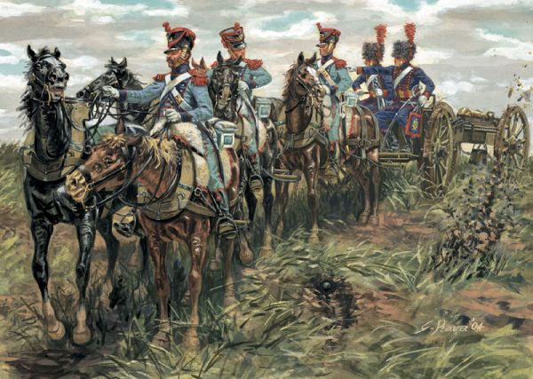
The profiles given for cannon are representative of an average of their type. The truth is that all cannons are slightly different, with each varying in different ways. To allow you to bring more variety and character to your cannon we've included rules for customizing them. Each upgrade is available to certain Cannon. You may purchase as many upgrades for each gun as you wish (see individual profiles for details). Unless otherwise specified, any cannon included in scenarios are unmodified and have no upgrades. See the individual Cannon entries for details.
LIMBER TEAM
The easiest way of moving a gun weighing several tons is with a team of horses. This grants the cannon much greater mobility and tactical flexibility on the battlefield. Should a cannon spend one turn in base contact with its limber, it is hooked up to the limber, and it may move at the speed of the horses pulling it. The crew of the gun automatically hop onto the limber, the gun, or the horses.
Type of Cannon | Number of Limber Crew Provided | Number of Horses Provided | Number of Horses Needed for Half Speed
3 pdr | 1 | 2 | 1
6pdr | 2 | 4 | 2
9pdr | 3 | 5 | 3
12 pdr | 3 | 6 | 4
18 pdr | 4 | 7 | 5
24 pdr | 4 | 8 | 6
5.5” Howitzer | 3 | 6 | 4

The Number of Limber Crew Provided is the number of trained crew provided if a limber is purchased for the gun. The minimum number of crew needed to drive the limber at full speed is half the number provided, rounded up. Only one of the crew must be Trained. If there are no Trained Limber Crew driving the Limber, and all untrained crew driving the limber, the Limber moves at half speed. Any Limber only needs one trained crewman to move at full speed. If there are no limber crew, the limber may not move.
The Number of Horses Provided is the number of horses provided if a limber is purchased for the gun. If the number of horses pulling the limber is greater than the Number of Horses Needed for Half Speed, the limber moves at the full speed of the horses.
If the number of horses pulling the limber is equal to the Number of Horses Needed for Half Speed, the limber moves at half speed. If there are less than the Number of Horses Needed for Half Speed, the Limber may not move. Cavalrymen may dismount and add their horses to a limber, should they desire.
 | F | S | D | A | W | C
Limber Crew (mounted) | 2/- | 3 | 3 | 1 | 1 | 2
Armed with daggers.
SUPERIOR CONSTRUCTION
The crew of this cannon are uncannily fast, aided by several non-standard refinements to its construction and their gunpowder. The range of this Cannon is increased by factor of 1.25, rounding up.
E.g. A 6 Pdr Cannon given this upgrade will have a range of 42 x 1.25 = 52.5 = 53”
SIEGE VETERANS
The crew of this Siege Engine have taken part in countless sieges and are adept at targeting weak spots in constructions. If a Siege Engine crewed by Siege Veterans successfully wounds a target, the controlling player may roll two dice on the Batter chart, not one, and apply the highest result. To receive this bonus, all crew must have the Siege Veterans skill.
MASTER GUNNER
The Master Gunner has devoted his career to gunnery, and is adept at his art. A crew with a Master Gunner attached may roll two dice when rolling to hit and rolling to scatter, and choose the highest. The Master Gunner may use his Might on behalf of the gun, exactly as an Engineer Captain does. Master Gunners may move between guns, giving this bonus to whatever gun they are crewing.
 | F | S | D | A | W | C | M | W | F
Master Gunner | 4/4+ | 3 | 4 | 1 | 2 | 4 | 1 | 1 | 1

Rockets
Primitive rockets were used in the Napoleonic Wars. They were used in many different sizes, but for simplicity, rules for only two are presented here.
Rocket Weight | Min. Crew (Moving) | Min Crew (firing) | Strength | Damage Radius | Nearby Damage Strength
24 lb | 4 | 3 | 9 | 3 | 6
12 lb | 3 | 2 | 7 | 2 | 4
All Rockets hit on a 5+, and have a Range of 80”. They do not receive any bonuses when rolling to hit for range. They will scatter up to 10”, and use a modified Scatter Chart. If there are less crew than indicated in the ‘Min Crew (firing)’ column, the Rocket Battery may not fire.
0-15 Enemy Models within Scatter Range |  | 15-30 Enemy Models within Scatter Range |  | 30+ Enemy Models within Scatter Range
Roll | Result | Roll | Result | Roll | Result
1 | Your opponent may nominate one of your Battlefield Targets or a Siege Target within Scatter Range of the initial target as the new target. If no alternative target is within Scatter Range, or the player does not wish to do this, the shot misses completely. | 1 | Your opponent may nominate one of your Battlefield Targets or a Siege Target within Scatter Range of the initial target as the new target. If no alternative target is within Scatter Range, or the player does not wish to do this, the shot misses completely. | 1 | Your opponent may nominate one of your Battlefield Targets or a Siege Target within Scatter Range of the initial target as the new target. If no alternative target is within Scatter Range, or the player does not wish to do this, the shot misses completely.
2-4 | The shot misses completely. | 2-3 | The shot misses completely. | 2 | The shot misses completely.
5 | The shot hits another enemy model within Scatter Range, as chosen by the opponent. | 4-5 | The shot hits another enemy model within Scatter Range, as chosen by the opponent. | 3-5 | The shot hits another enemy model within Scatter Range, as chosen by the opponent.
6 | The shot hits the original target. | 6 | The shot hits the original target. | 6 | The shot hits the original target.

The model hit is struck with a blow of the Strength of the rocket. He is knocked to the ground. If wounded once, he is killed outright. All models within the ‘Damage Radius take a hit of the ‘Nearby Damage Strength,’ and are knocked to the ground, but not killed outright if wounded.
Rocket Batteries may be moved at half speed by the half the number of models, rounded up, indicated in the Min. Crew (moving) column. If there are more than half the Min. Crew, rounded up, the Battery may be moved at the full speed of the slowest model. If there are less than half the Min. Crew, the Battery may not move.

Profiles
The profiles for a number of Napoleonic units follow. They are sorted into Nations, and their respective Unit types – i.e. Hussars, Line Infantry, etc. For each troop type taken, the player must take at least one officer or NCO of the same troop type.
At the beginning of each Nation, there is a selection of Personalities. A Personality may count as any troop type. This means that, for example, a French player could take 5 Old Guard Grenadiers and Michel Ney instead of taking an Old Guard Grenadier Sergeant. Personalities may only count once in this way. This means that Michel Ney in the aforementioned example would not permit the player to take 5 Hussars without a Hussar NCO, Hussar Captain, or another Personality. The exception to this rule is Sappers.

